Dear <<Insert Name Here>>,
I’m writing to tell you about an opportunity to join the SMS community, free of charge, to receive the latest information and opportunities from the Smith-Magenis Syndrome (SMS) community. PRISMS is a 501c3 organization dedicated to serving the global Smith-Magenis Syndrome community of families and professionals with programs and services focused on education, awareness, and research. PRISMS is committed to ensuring that all of those impacted by SMS have the resources and opportunity to achieve their fullest potential. By completing a simple online form, you are connecting with a community that cares.
To join our community: https://www.prisms.org/community/

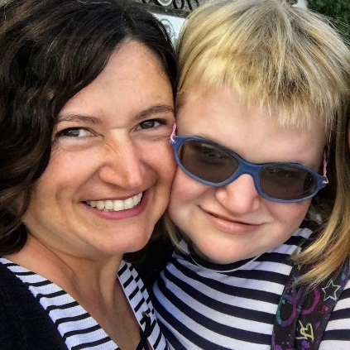
Some Reasons Why It’s Important to join the SMS community
Foster research and scientific awareness - With membership, you gain access to research updates sent directly to your email, including information on the latest in SMS research following each SMS Research Symposium
Access to the International SMS Conference -As a member, you’ll receive regular updates on PRISMS International SMS Conference directly to your email
Join a growing international community- We encourage families, researchers and educators around the world to become part of our organization. Membership is open to everyone. PRISMS has members from more than a dozen countries around the world!
Stay in touch with PRISMS - As a member, you will receive quarterly Spectrum Journals via email with the latest news about families, research and the organization. You will also receive the latest news and information from PRISMS emailed to you about critical topics such as our international conference, research studies or updates on key developments that affect your family and/or patients/clients
Having you join this community as a member to receive the latest information on SMS means a lot to me. To learn more about SMS and membership, visit www.prisms.org.
Thank you,

<<Insert Your Name Here>>

